Add interCS logo

12/14/2018

Enable prospects to register for a newsletter, listing or webinar, and to add your company automatically to their address book!
Registering for a newsletter
Summary
Enable prospects/people to register for eg. a newsletter, confirm with email to prospect, prospect enabled to add your contact information to his/her address book.
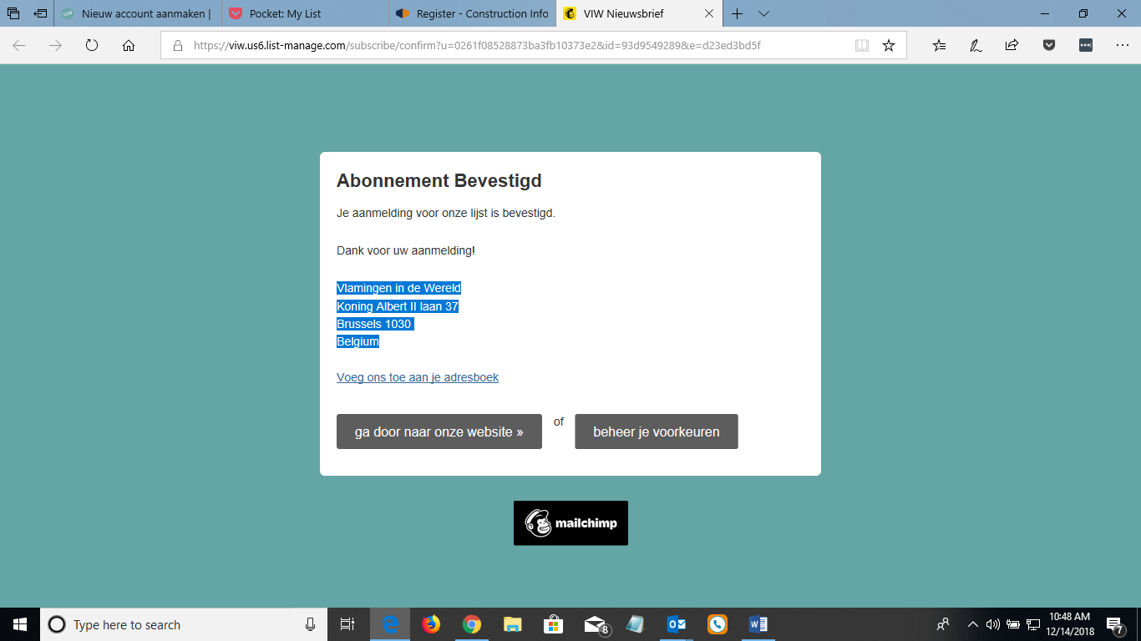

- Prospect adding your company contact information to eg. His outlook email contacts
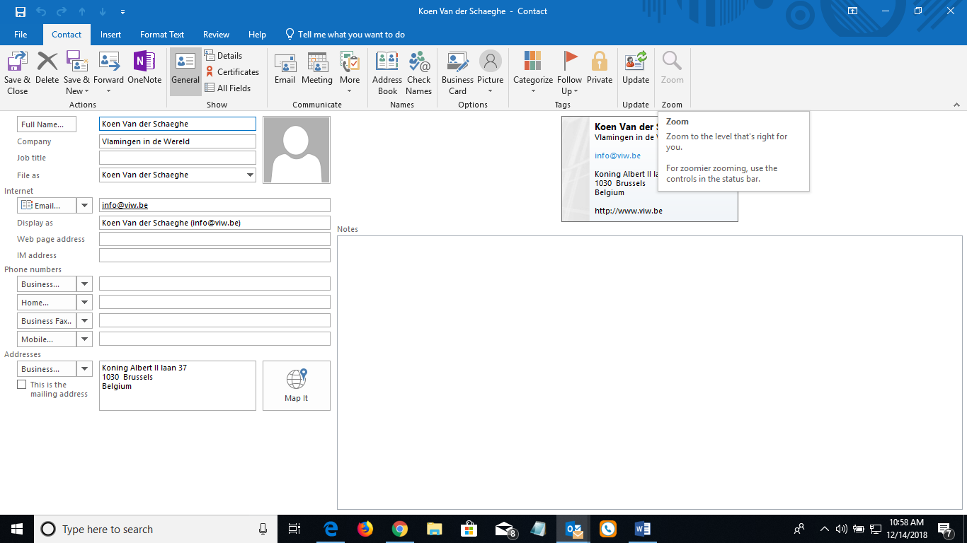
- ..
- ..
- 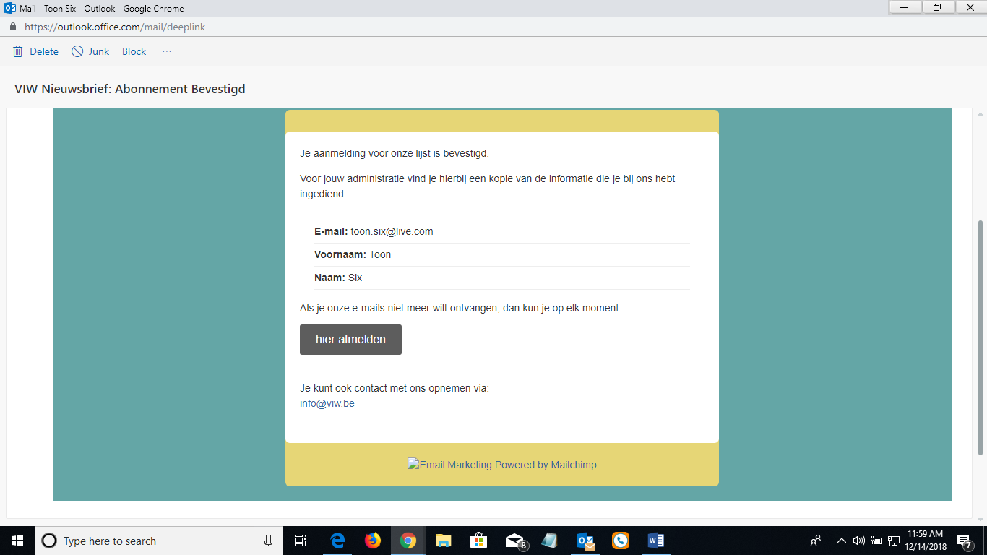

An English example with www.CISLeads.com: Registering to add your company as a listing in the supplier’s business directory
- Send an email to a prospect, and include a weblink to you website page where they can register to eg. Add their company to your business directory or eg to get your company newsletter, or eg to join a discussion forum (yammer), or eg. To join a private portal MS Teams, or eg to join a webinar, …
- Register with eg. CisLeads to eg. Add your company listing to their business directory
  - Go to www.CISLeads.com
  - 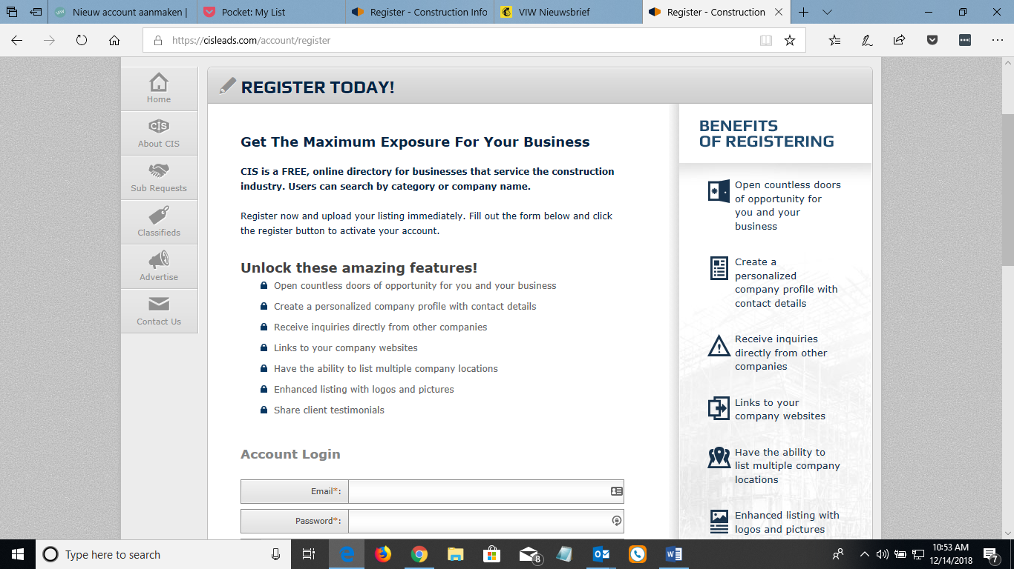
  - ..
  - Confirmation/acknowledgement of your registration advising to check your email for a verification action

  - 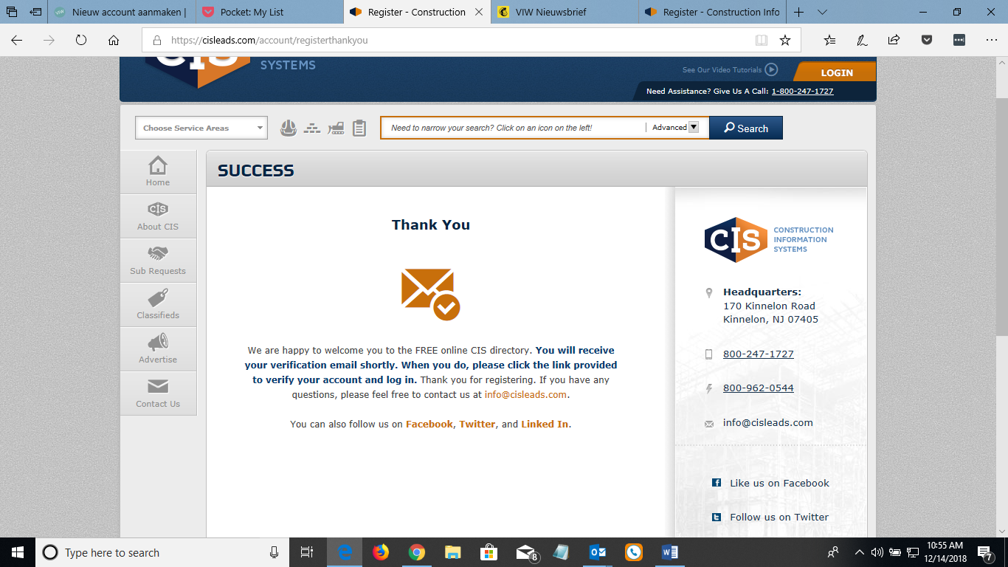
- Verification Email
  - ..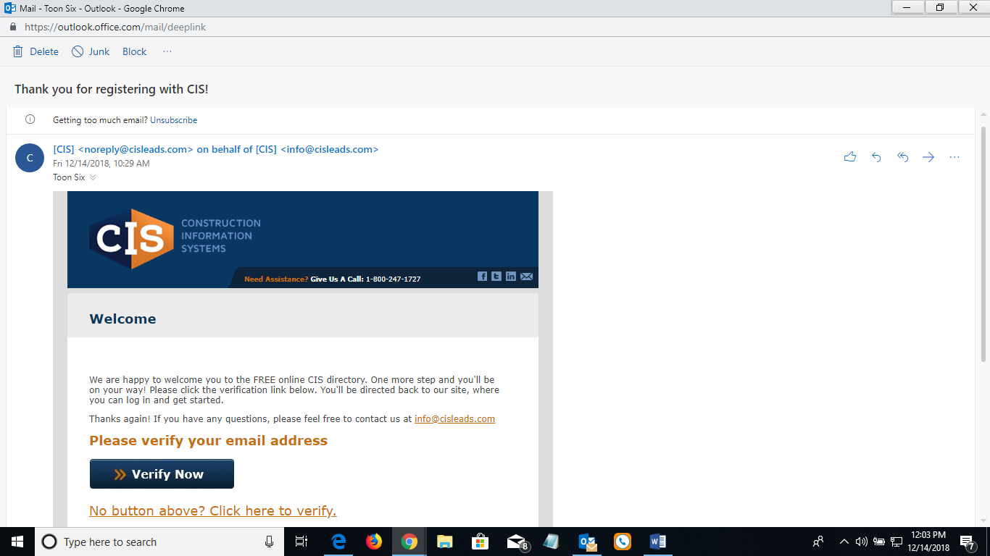
  - ..
  - Opt out option is included.
  - 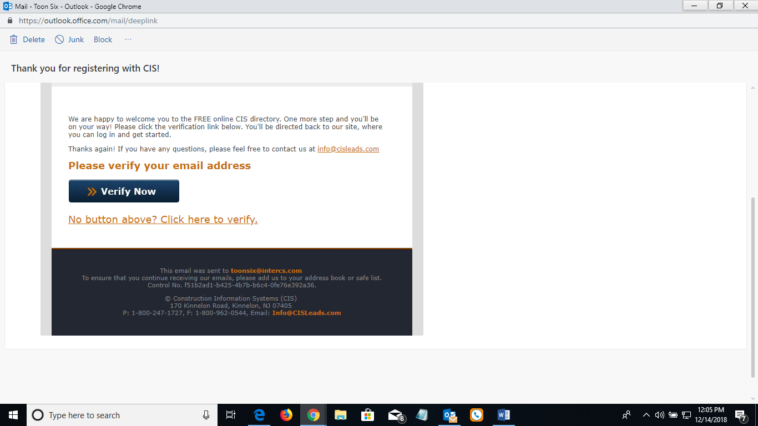
  - ..
  - Click on Verfy Now, which will take you to the supplier’s website, and ask you to start adding your company information for the listing
  - 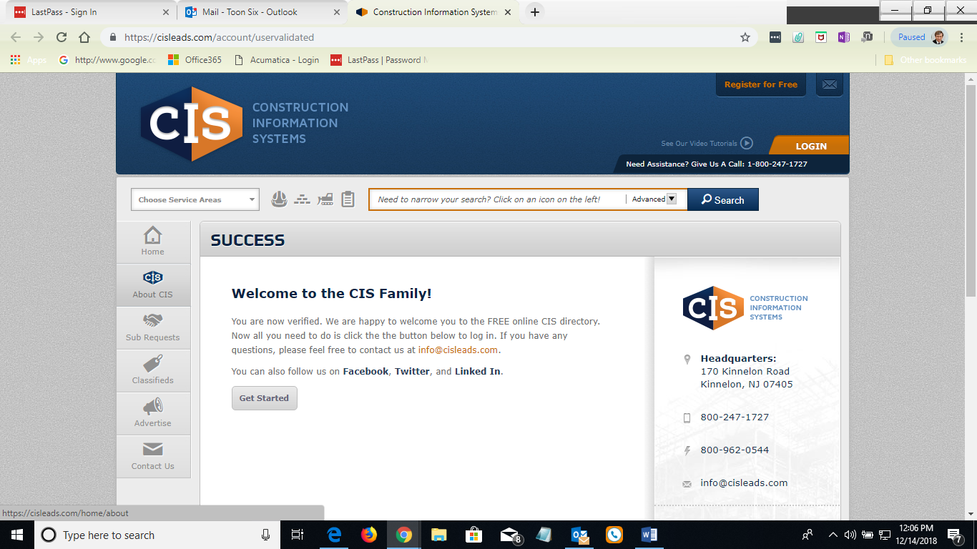
  - It would have been greater if the supplier enabled the customer to add the supplier information to their address book using a VCF file. This way, if there is a problem, the customer can email right away the supplier for help.
  - In email or on website there is link: “Add us to your website.
  - ..
  - 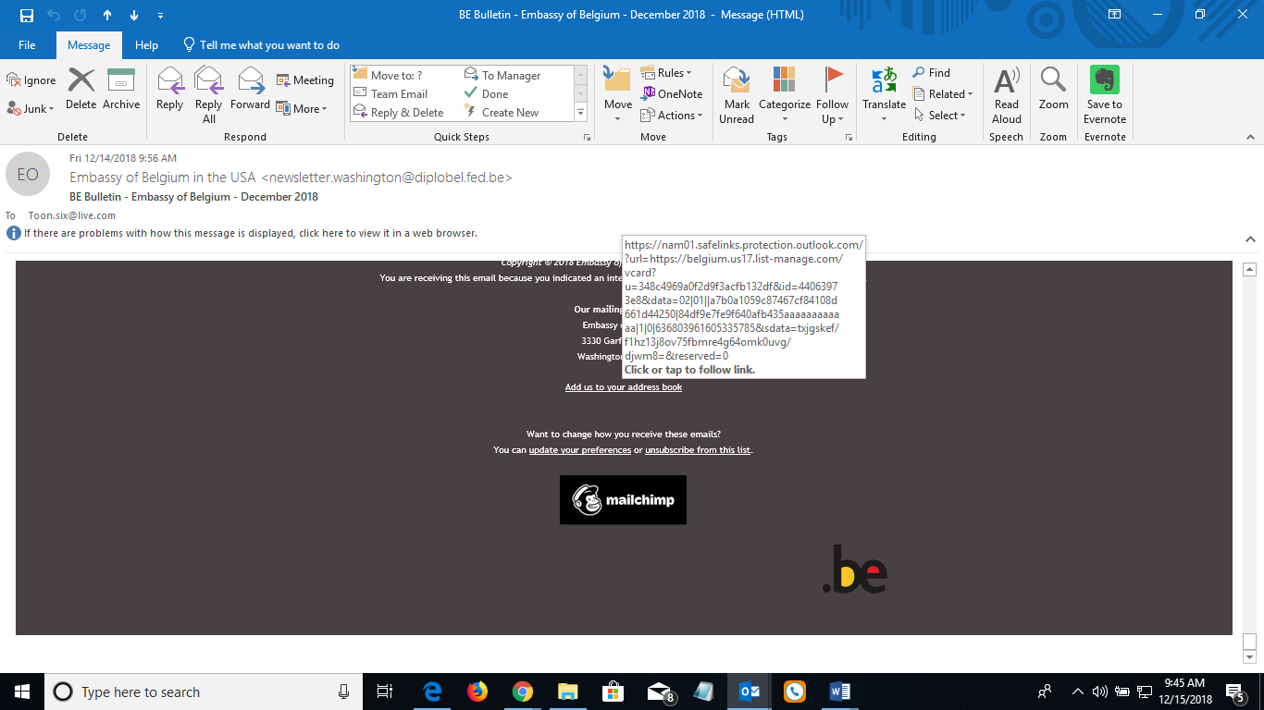
  - Click on this link
  - 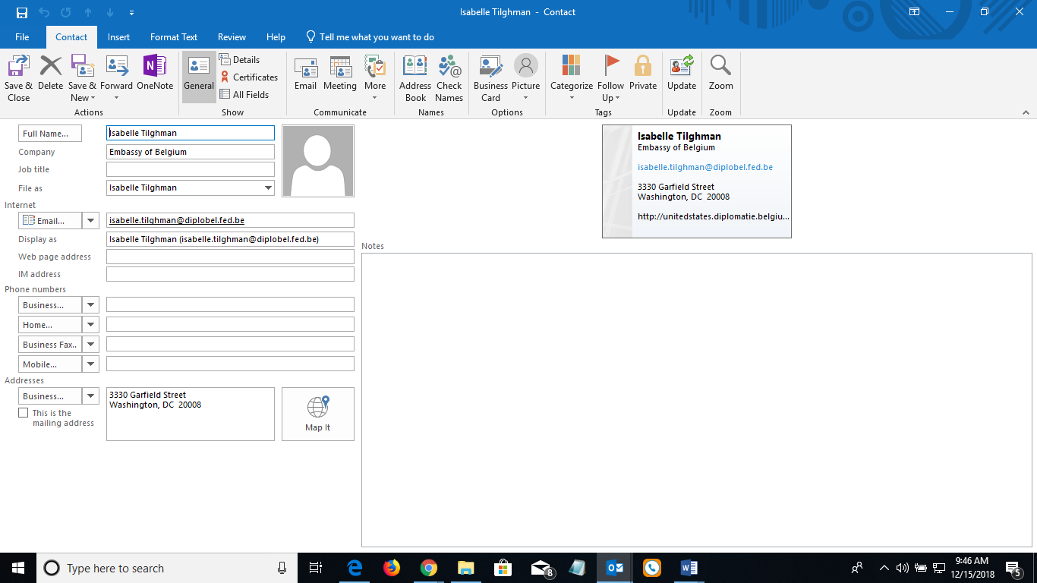

Another Example of registering for a webinar, and adding automatically webinar date to your calendar
- Send out HTML email about the webinar
  - 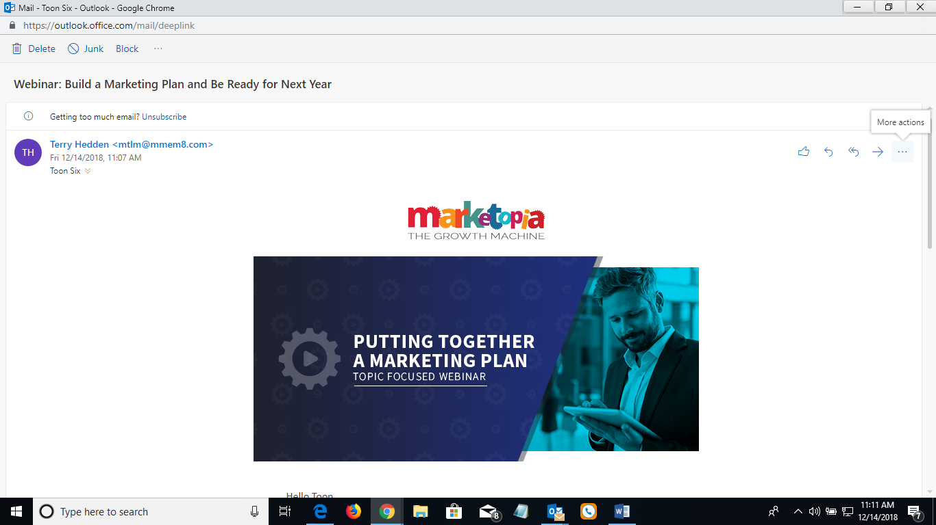
  - ..
  - 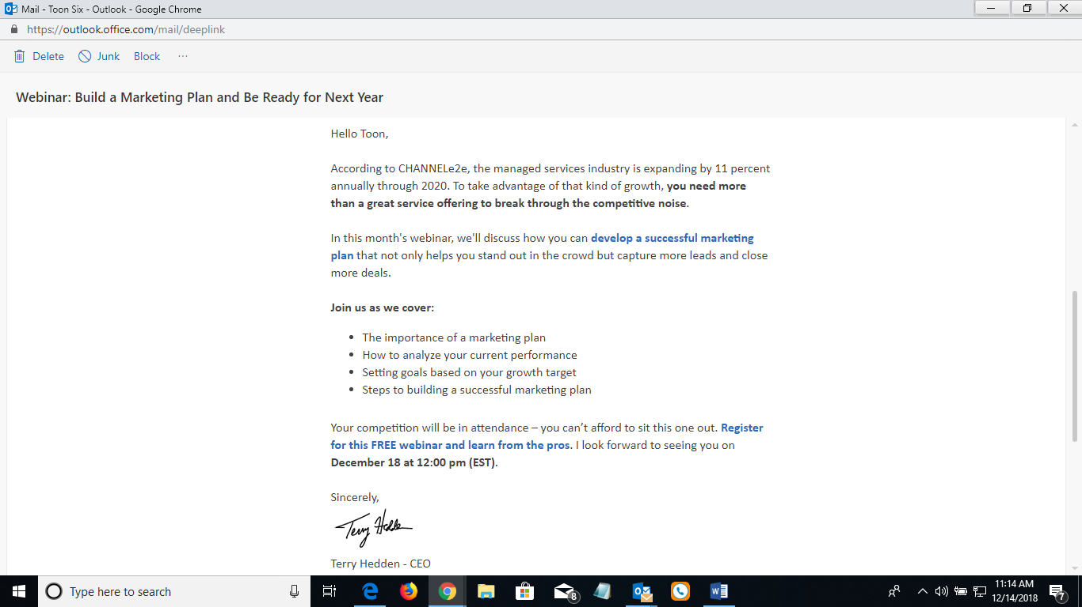
  - ..
  - 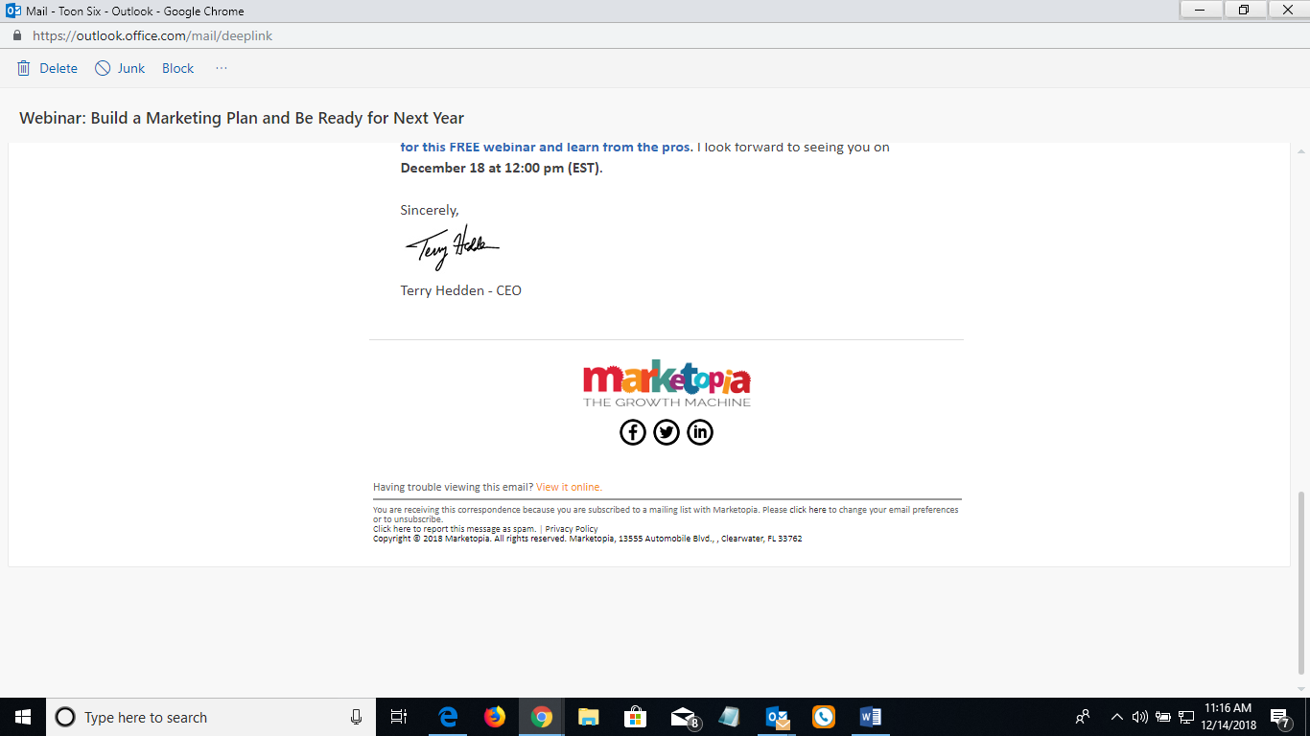
  - ..
- Register for webinar
  - Email link brings you to vendor’s website or to GoToWebinar or go to GoToMeeting (LogMe in) website to register for webinar. Or go to MS Teams (meeting) website ??? or to RingCentral Meeting website as Acumatica ISV webinars use.
  - 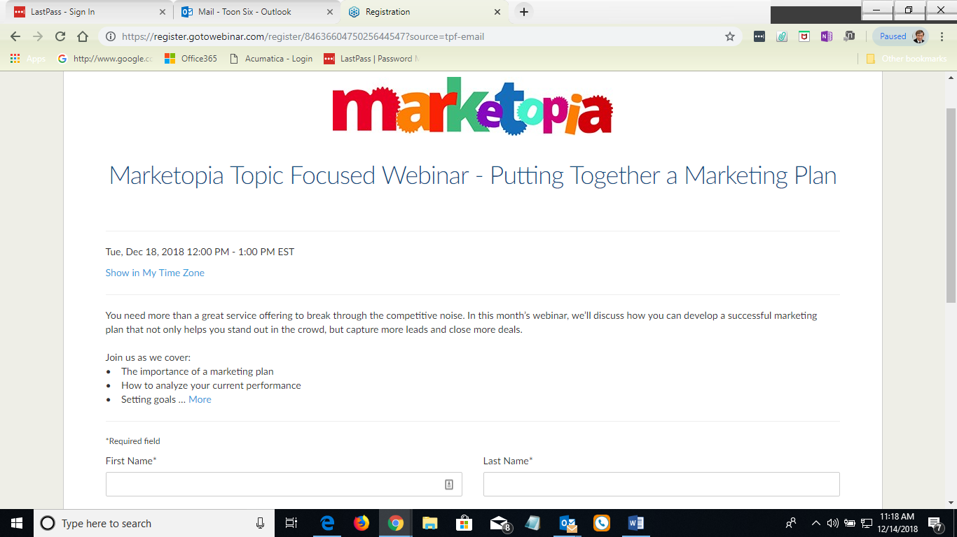
  - ..
  - 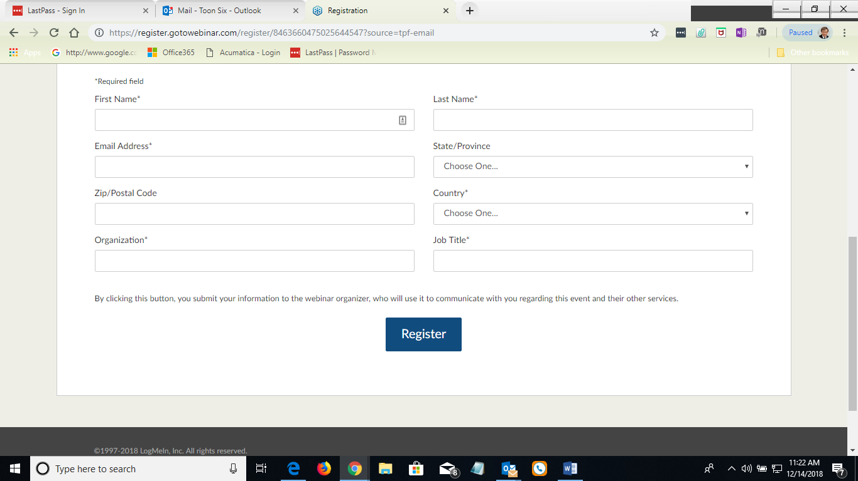
  - ..
  - Vendor’s website responds with another webpage confirming registration, how to Add to Calendar, and instructions, and contact information.
  - 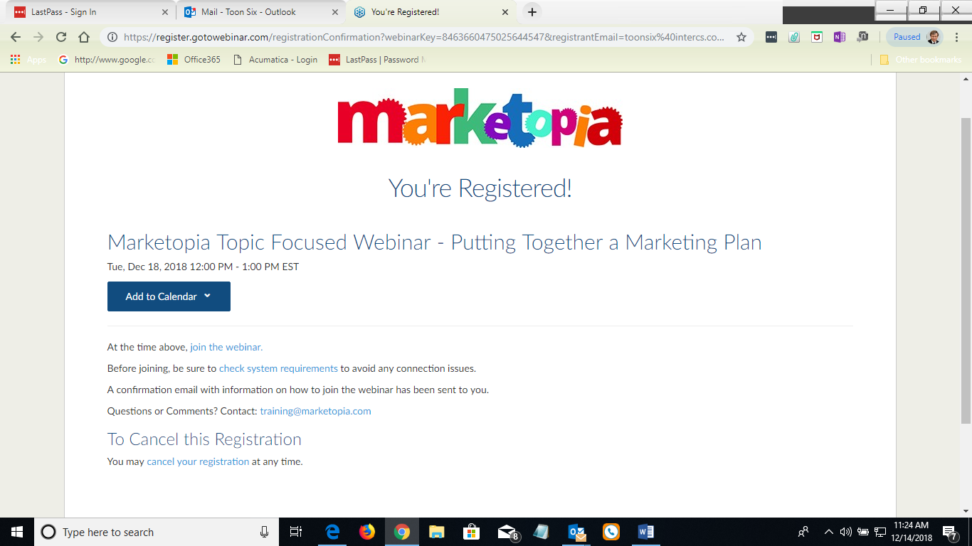
  - ..
  - Add to calendar
  - 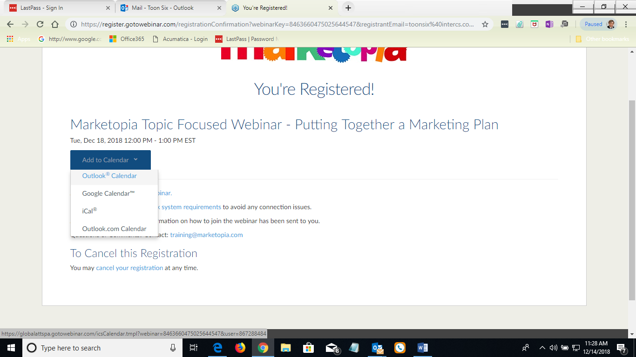
  - ..
  - Choose Outlook Calendar ( MS Outlook email client)
  - 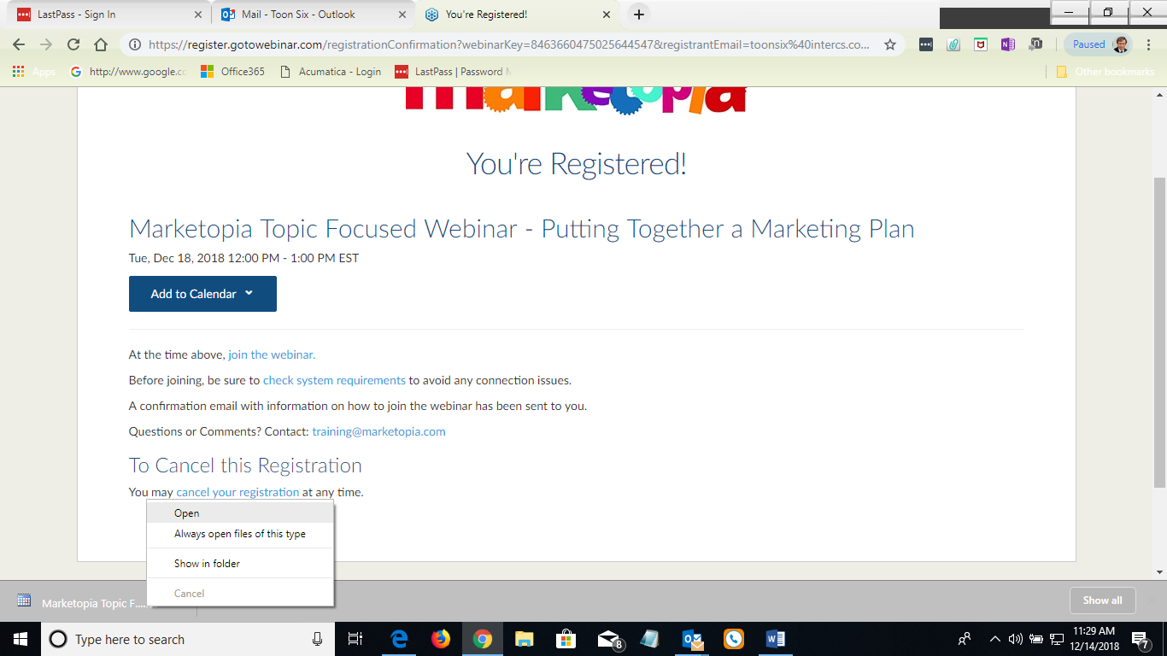
  - ..
  - Click on Open
  - 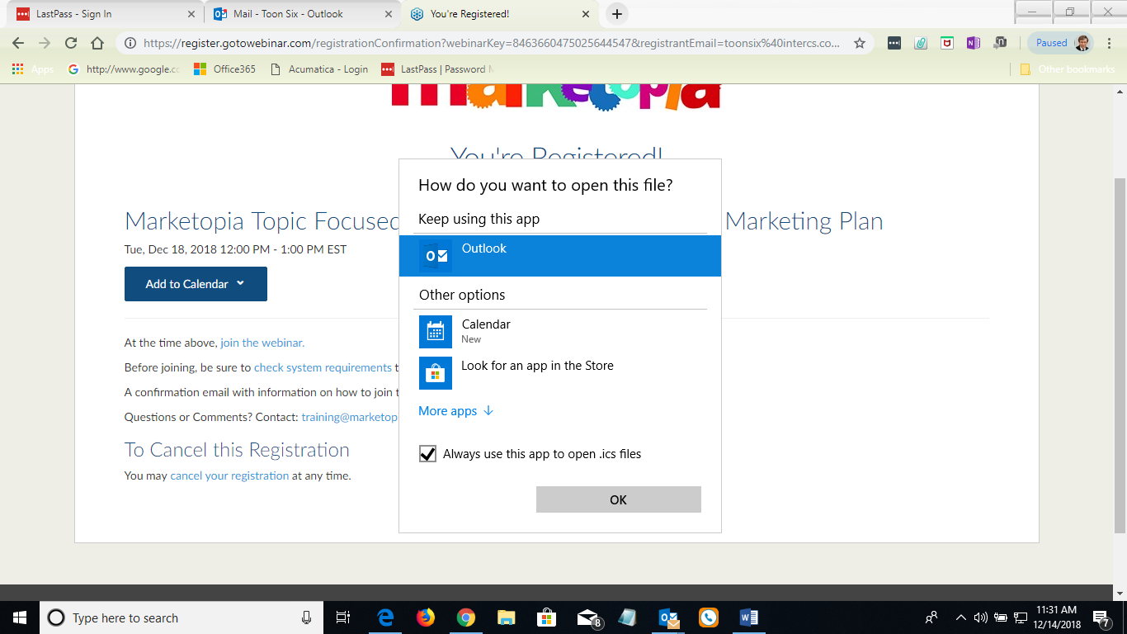
  - Select Outlook to have it in my MS Outlook client software that is already running for toonsix@intercs.com

  - If I selected outlook.com, it will ask to install an applet
  - 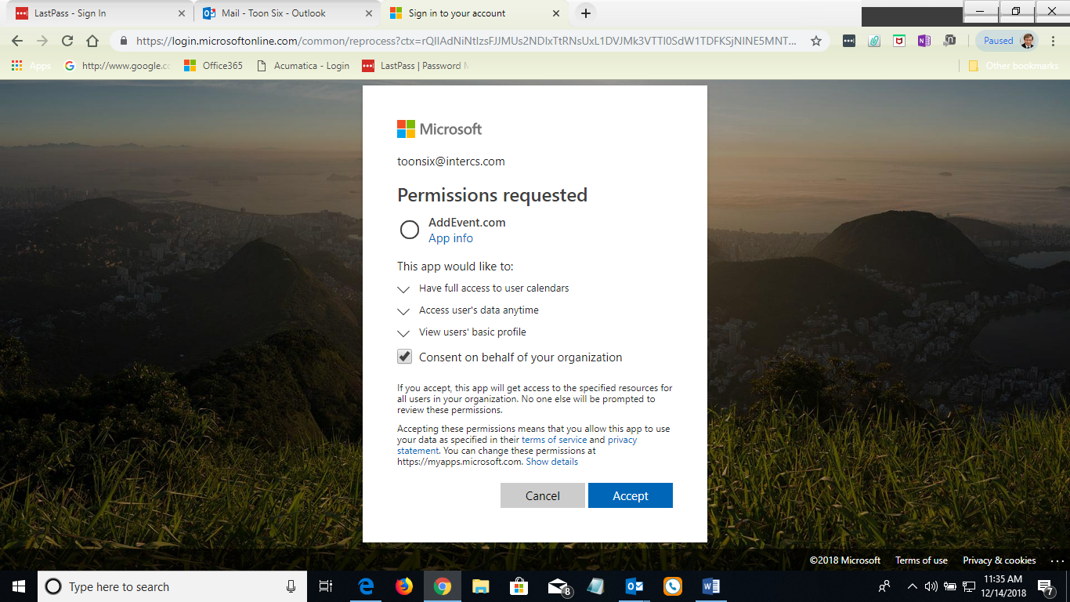
  - ..
  - Event added to calendar
  - ..
  - 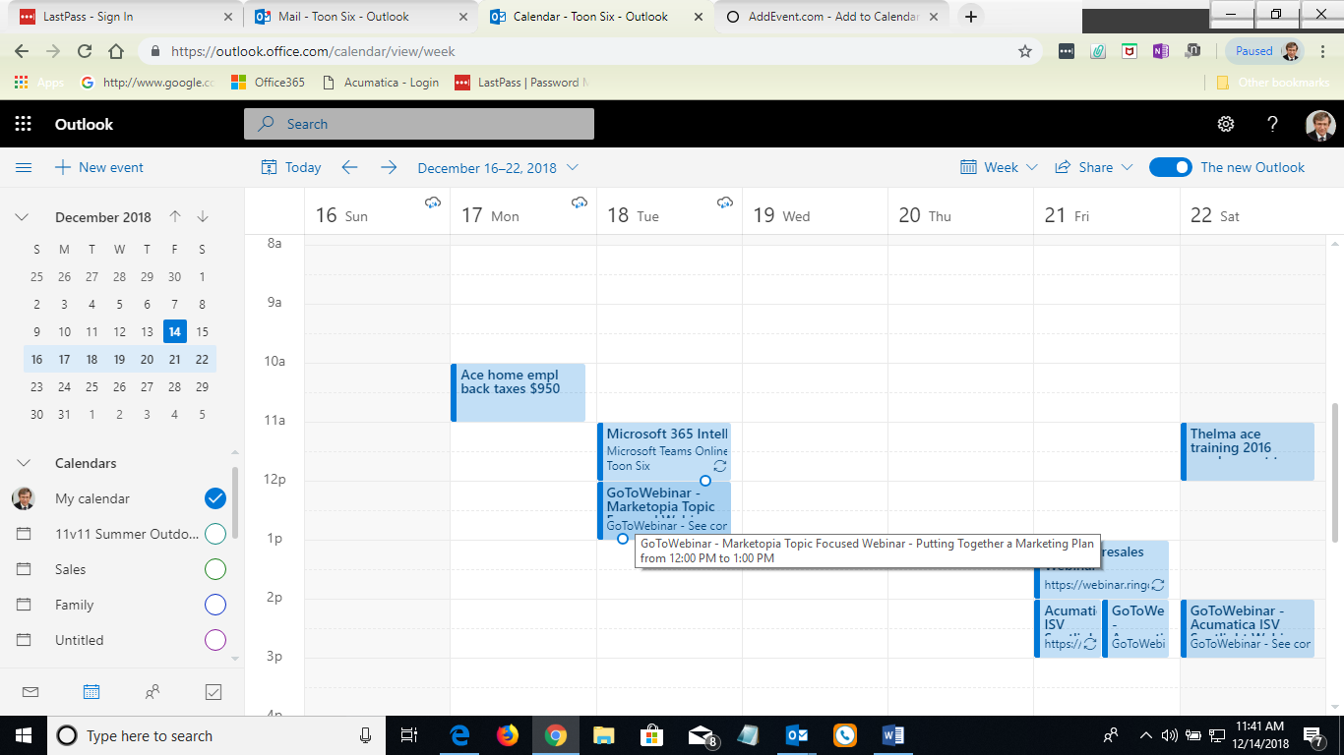
  - ..
  - 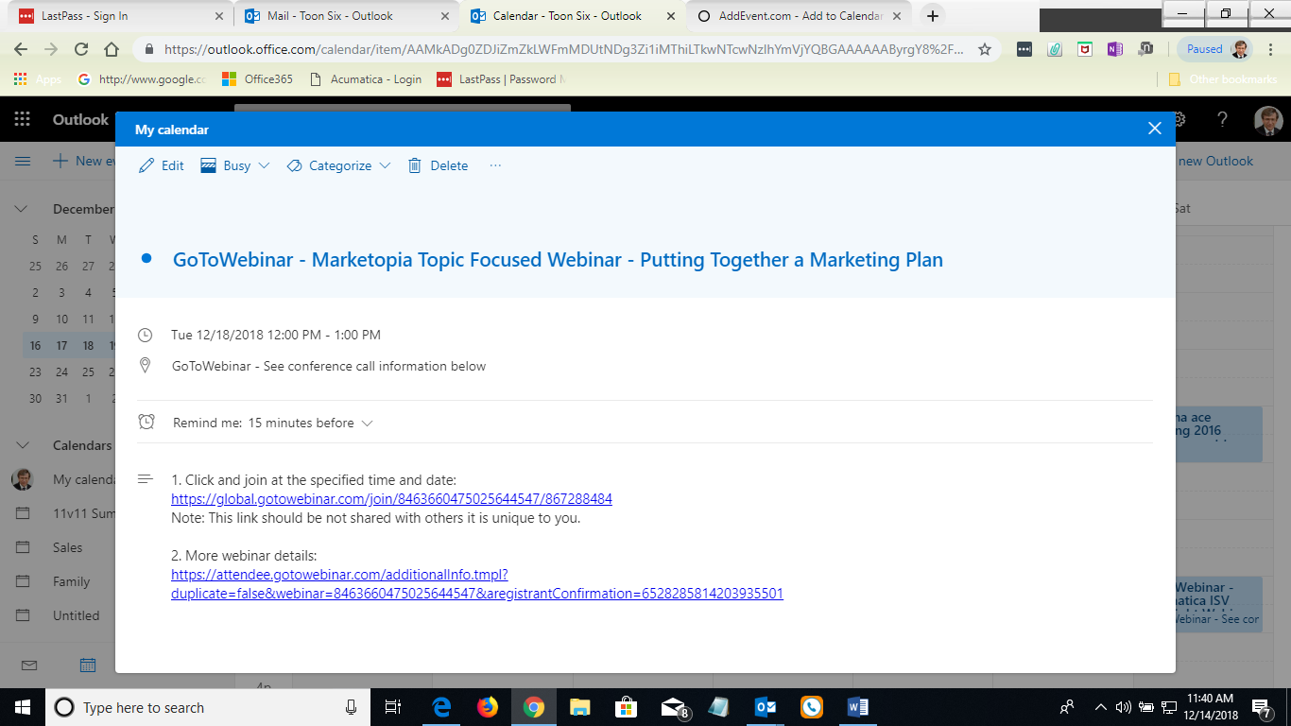
  - .
  - Email was also sent to registrant
  - 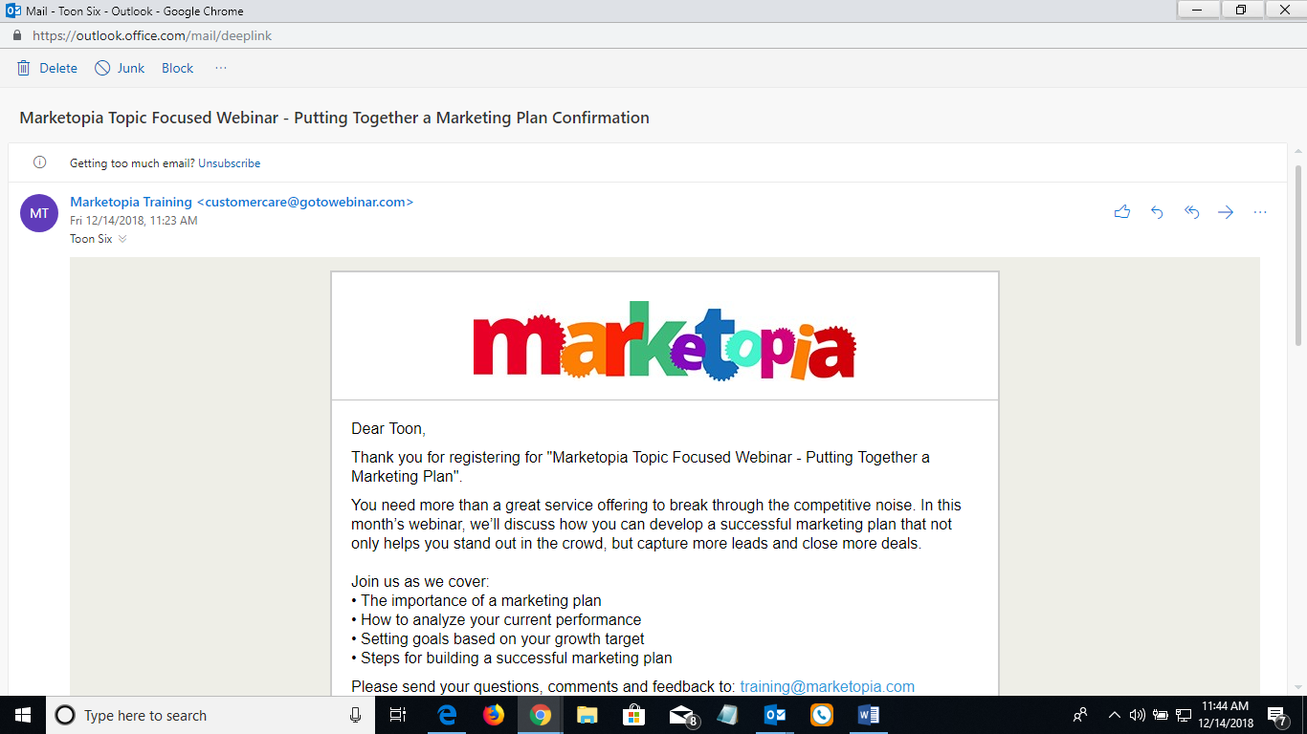
  - .
  - 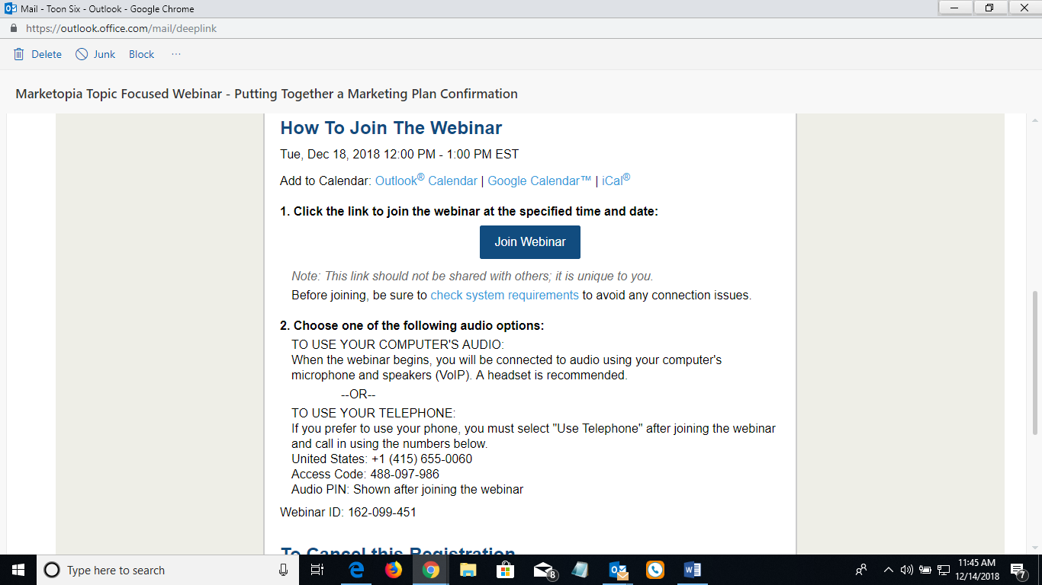
  - ..

Tools used to do this
- Mailchimp
- Acumatica CRM form
  - Use Acumatica ERP form??
    - Marketing campaign: distribution list, add new subscriber
  - Distrib list for newsletter, one for webinars, one for ..
- Add Us browser plug in

